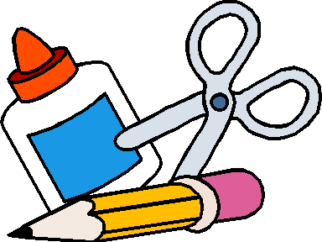
8 Fat Beginner Writing Pencils
Preschool Back to School List
2 package of fat markers, preferably Crayola (they are washable)
2 package of crayons
8 Elmer glue sticks
1 pair of blunt tip scissors
1 Crayola Water color paint set
2 Pack of FAT Dry Erase Markers
2 Pack of Fine Tip Dry Erase Markers
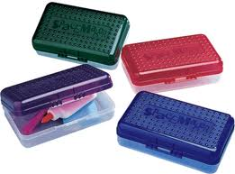
1 small box to store supplies in

2 container of baby wipes, unscented
1 pack of non-shiny paper plates (cheap ones are the best)
4 boxes of tissues
1 backpack to carry supplies and folders back and forth in
1 crib size blanket, small pillow carried in a reusable bag
2 box of gallon-size Ziploc bags
2 box of Quart-size Ziploc bags
1 extra set of clothes, pants, shirt, 2 underwear, socks and indoor shoes labeled with your child’s name on them to leave at school.

